GlobalMart - Architecture Document
Medallion pipelines (`Bronze.py`, `Silver.py`, `Gold.py`) + Gen AI notebooks (UC1–UC4).

Data flow diagram (end-to-end)
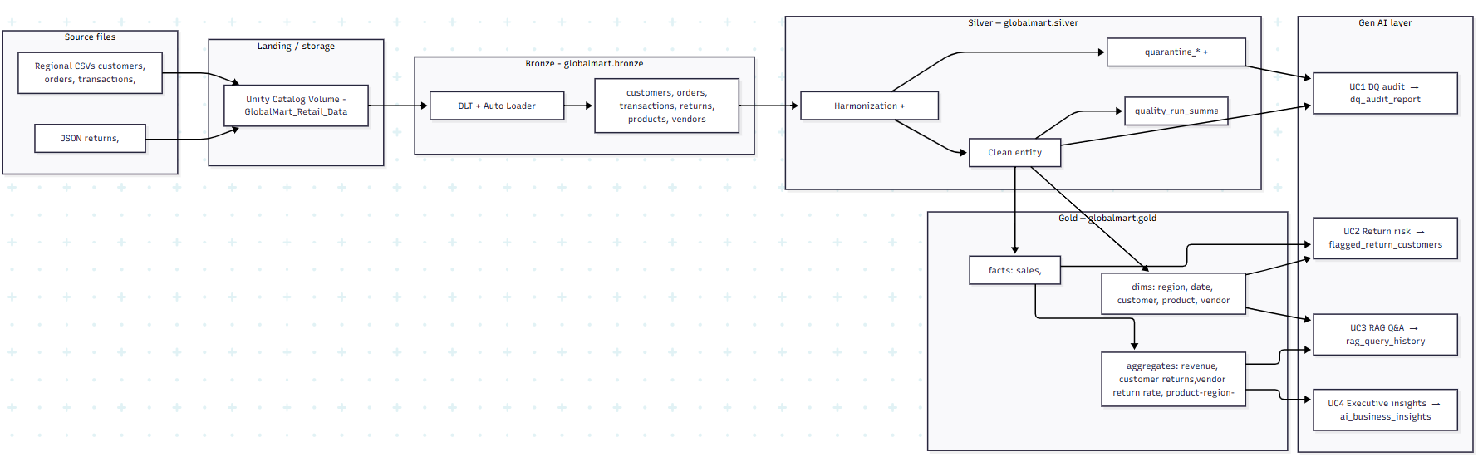

Narrative (source → user): Regional CSV and JSON files land in a Volume. Bronze ingests them incrementally (Auto Loader), preserving lineage. Silver standardizes schemas, applies data quality rules, and splits pass vs quarantine rows. Gold builds a star schema (dimensions + facts) and pre-aggregates KPIs. Gen AI notebooks read Silver quarantine and/or Gold tables and write Gold Delta tables with narratives or scores. Finance, returns, and merchandising consume results via Unity Catalog, SQL, and dashboards.

2. Component map

Component | Layer | Role
CSV / JSON source files (GlobalMart_Retail_Data/) | Source | Authoritative retail extracts (multi-region).
Unity Catalog Volume (/Volumes/globalmart/raw/landing_files/...) | Landing | Stores raw files for Auto Loader paths in Bronze.py.
Delta Live Tables (DLT) — Python | Pipeline orchestration | Declarative tables/views; Bronze + Silver + Gold pipelines.
Auto Loader (`cloudFiles`) | Bronze | Streaming ingestion; schema hints + evolution at _schemas/dlt_bronze.
Apache Spark / PySpark | Bronze–Gold | Transformations, joins, windowing, aggregates.
Delta Lake | Bronze–Gold + AI outputs | ACID tables, time travel, saveAsTable / DLT targets.
Unity Catalog (globalmart catalog, bronze / silver / gold schemas) | Governance | Table discovery, ACLs, lineage to consumers.
Databricks Notebooks | Development / Gen AI | UC1–UC4: LLM calls, RAG, ai_query() demos.
OpenAI-compatible client (openai SDK, Databricks token) | Gen AI | Calls serving endpoint `databricks-gpt-oss-20b`.
Sentence Transformers + FAISS (UC3) | Gen AI | Local embeddings + vector search for RAG.
`ai_query()` (UC4 SQL cells) | Gen AI | SQL-side LLM prompts on KPI JSON.

3. Data quality strategy (by layer)

Bronze
- Ingest as-is with `_ingest_timestamp` and `_source_file_path` for lineage.
- Schema discipline: inferSchema=false + Auto Loader schema location + `addNewColumns` evolution.
- Format handling: CSV with header; JSON multi-line; recursive file lookup for regional paths.

Silver
- Harmonization: One canonical id per entity (e.g. coalesce regional customer_id variants); timestamp and money parsing; segment/region/return-status normalization; Region 4 city/state fix using file path.
- Row-level rules encoded in `failure_reasons` (semicolon-separated tokens), e.g. null keys, invalid vendor pattern, non-US country (customers), negative sales (transactions), invalid return status (returns), etc.
- Split outcomes: Valid rows → `globalmart.silver.<entity>`; invalid → `globalmart.silver.quarantine_<entity>` (retains failure_reasons).
- DLT expectations (`@dlt.expect`) on silver tables for critical columns (e.g. non-null ids, vendor VEN## pattern on orders).
- Monitoring: `globalmart.silver.quality_run_summary` — accepted vs rejected counts per entity per run.

Gold
- Consume only trusted Silver pass tables (no quarantine in facts/dims).
- Referential consistency enforced by join design (e.g. fact_sales inner-joins orders + customers).
- Business definitions fixed in facts/aggregates (grain documented in Gold.py comments).

4. Analytics layer structure (Gold — top of stack)
Catalog: globalmart.gold

Dimensions (descriptive context)

Table | What it measures / holds | Keys / notes
dim_region | Distinct regions from customers | region_key, region_name
dim_date | Calendar attributes for order and return dates | date_key (YYYYMMDD), year, quarter, month, year_month
dim_customer | Customer attributes: segment, region, address | customer_id → links to facts
dim_product | Product catalog (from Silver products) | product_id → links to fact_sales
dim_vendor | Vendor reference | vendor_id → links to facts

Facts (events / line-level measures)

Table | Grain | What it measures
fact_sales | One row per order line (order + product) | sales_line_key, order_id, product_id, customer_id, vendor_id, region_key, date_key, year_month, sales_amount, quantity, profit, discount_rate, discount_amount, flags
fact_return | One row per return | return_key, order_id, refund_amount, return_date / return_date_key, return_status, vendor_id, customer_id, region_key

Aggregates (KPIs for dashboards and AI)

Table | Grain | What it measures
agg_monthly_revenue_by_region | Month × region | total_sales, total_profit, order_count, total_quantity
agg_customer_return_summary | Customer × region | return_count, total_refund_amount, avg_refund_amount
agg_vendor_return_rate | Vendor | vendor_gross_sales, vendor_refunds, `refund_to_sales_ratio`
agg_product_region_monthly | Product × region × month | total_sales, total_quantity, total_profit, order_count

How they relate
- Facts connect to dimensions via `customer_id`, `product_id`, `vendor_id`, `region_key`, `date_key` / `year_month`.
- agg_* tables roll up fact_sales and/or fact_return (and join dim_region or dim_vendor where names are needed).
- Star schema pattern: filter/slice on dimensions and aggregates; drill to facts for detail.

5. Generative AI integration
Position: Sits above Gold (and selectively Silver quarantine for DQ detail), writes back to Gold Delta tables or logs; does not train on raw Bronze.

Use case | Notebook | Inputs (what goes in) | Outputs (what comes out)
UC1 — AI Data Quality Reporter | UC1 Designing the AI Data Quality Reporter.ipynb | `globalmart.silver.quarantine_*` (failure_reasons exploded by issue), mapping issue_type → field; optional alignment with `quality_run_summary` | `globalmart.gold.dq_audit_report` — per-entity, per-issue plain-English audit narratives + counts
UC2 — Returns fraud / risk | UC2 Engineering the Returns Fraud Investigator.ipynb | `fact_return`, `dim_customer`, `fact_sales` — rule-based anomaly_score, thresholds | `globalmart.gold.flagged_return_customers` — risk scores, rules violated, AI investigation brief
UC3 — Product / vendor Q&A (RAG) | UC3 Building the Product Intelligence Assistant.ipynb | `dim_product`, `dim_vendor`, `agg_product_region_monthly`, `agg_vendor_return_rate` (enriched documents) | `globalmart.gold.rag_query_history` — question, grounded answer, retrieved doc metadata
UC4 — Executive BI | UC4 Synthesizing Executive Business Intelligence.ipynb | KPI JSON from `agg_monthly_revenue_by_region`, `agg_vendor_return_rate`, `agg_product_region_monthly` (no raw-row prompts) | `globalmart.gold.ai_business_insights` — insight_type, executive_summary, kpi_payload_json; plus `ai_query()` demos in SQL

Model: `databricks-gpt-oss-20b` via Databricks serving endpoints (OpenAI-compatible API). UC3 adds sentence-transformers + FAISS for retrieval.

